Objective of this assignment:

Implement Dijkstra’s algorithm

* USE THIS FILE AS THE STARTING DOCUMENT YOU WILL TURN IN. **DO NOT DELETE ANYTHING FROM THIS FILE:** JUST **INSERT** EACH ANSWER **RIGHT AFTER ITS QUESTION/PROMPT**.
* IF USING HAND WRITING (STRONGLY DISCOURAGED), **USE THIS FILE** BY CREATING SUFFICIENT SPACE AND WRITE IN YOUR ANSWERS.
* FAILING TO FOLLOW TURN IN DIRECTIONS /GUIDELINES WILL COST **A 30% PENALTY.**

What you need to do:

Complete the assigned these three tasks:

1) Implement Dijkstra’s algorithm

2) Compile, execute and take a screenshot of a successful execution using a provided input graph called graph.txt

3) Compile, execute and take a screenshot of a successful execution using your own input graph called myInputGraph.txt

Objective of this assignment:

* Implement Dijkstra’s algorithm

What you need to do:

1. **Ask questions if you have any doubt**
2. Implement Dijkstra’s algorithm
3. Allow a user to provide a *graph* and a *source* vertex $s$ as a text file.
4. Display the shortest path for $s$ to every other vertex in the graph.
5. Output a file text describing the shortest path for s to every other vertex in the graph
6. **Ask questions if you have any doubt**

**Objective**:

The objective is to implement the Dijkstra’s algorithm.

**Input**:

Your program must prompt the user to enter the name of an input file text. The input will be a text file describing the graph. For simplicity, vertices will be identified using only characters "a, b, ..., A, .., Z". The weights on the edges will be positive integers from 1 to 32,767.

A graph and the source $s$ are provided in the text file on Canvas under the name *graph.txt* following this format:

s

t x,1 y,2

s t,10 y,5

y z,2 t,3 x,9

x z,4

z x,6 s,7

The first line provides the **source** vertex. For this example, Node s is the source. The remaining lines provide the adjacency list. The leftmost column is the list of vertices (here, vertices are s, t, y, x, z). For each vertex, the edges are provided as pairs node, weight. For example, Vertex t has two edges:

- the first edge is x,1 meaning the edge (t,x) with weight 1

- the second edge is y,2 meaning the edge (t,y) with weight 2

A node not connected to any other vertex will be listed with no edge(s).

The above input text file graph.txt (available on Canvas with this assignment) represents the graph below with Vertex s as the source:

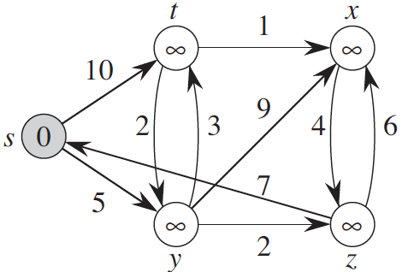

**Output**:

If the Dijkstra’s completes **successfully**, the output will provide the shortest path from the source to each vertex in the graph other than the source. You must display the output and write it to a text file under this format:

t: y t

y: y

x: y t x

z: y z

The first column is the list of nodes in the graph (except the source) in the order used in graph.txt. For each vertex, the shortest path is provided as a list of vertices describing the path. For example: the shortest path from s to x is the path s y t x (see output file above)

**Programming**

You can implement the Dijkstra’s algorithm in your preferred language as long as it is already available on Engineering Tux machines. Insure that your program compiles and executes correctly on Tux machines.

**Tasks**:

**Task 1**

Implement the Dijkstra’s algorithm

**Task 2**:

- Log on a Tux machine

- Type the date command

- compile your program

- Execute your program using the provided input file grah.txt.

- Display the shortest path under the provided format

- Take a readable screenshot showing the date, your username, the tux machine name, the compilation directions, the execution and the shortest path. The screenshot must be as readable as this template screenshot:

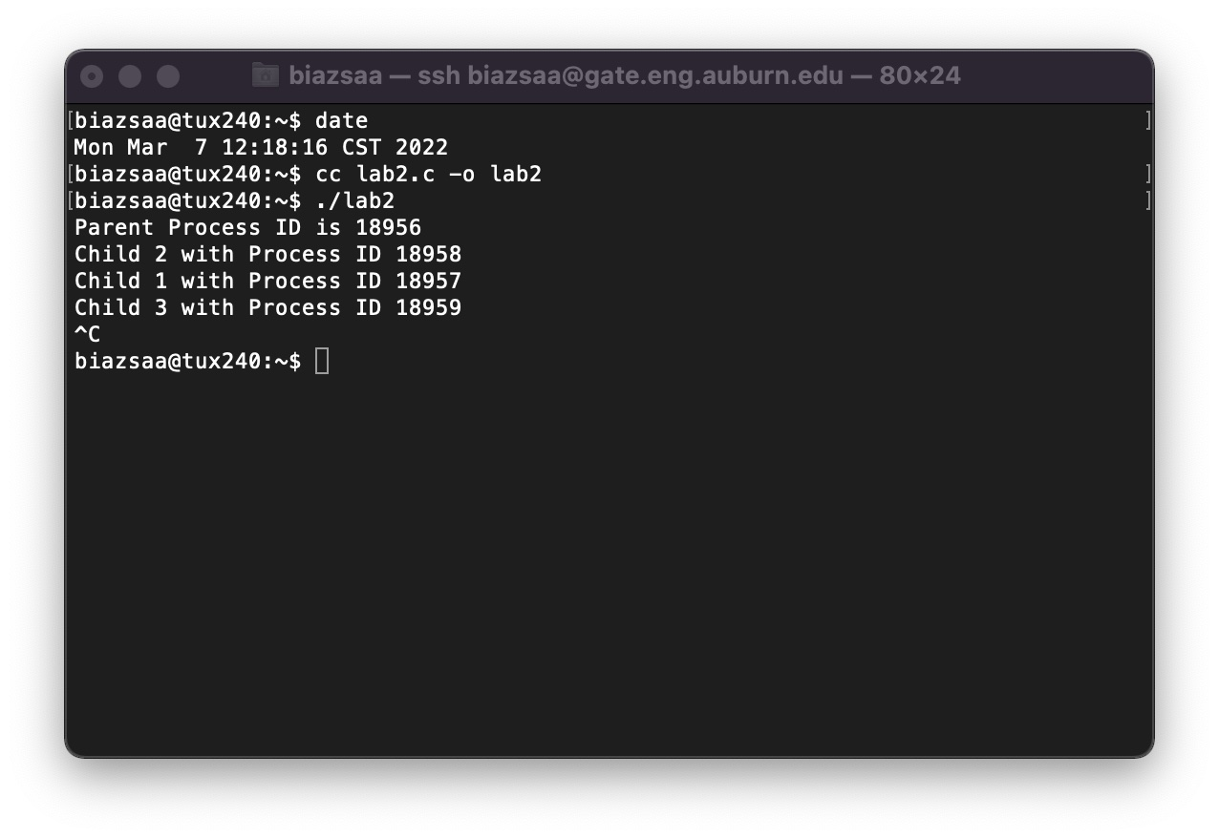

As shown in the screenshot above, there are 2 separate java files that need to be compiled in order to get my program to work. This first screenshot is for using the example graph.txt file

Insert your screenshot here

**Task 3**:

- Prepare your sample input graph file. This sample graph file (with .txt extension) must have at least 8 vertices and 16 edges. Call this file myInputGraph.txt. The output text file of your program must be called outputShortestPaths.txt,

- Log on a Tux machine

- Type the date command

- compile your program

- Execute your program using your input file myInputGraph.txt.

- Display the shortest path under the provided format

- Submit the files myInputGraph.txt and outputShortestPaths.txt.

- Take a readable screenshot showing the date, your username, the tux machine name, the compilation directions, the execution and the shortest path. The screenshot must be as readable as this template screenshot:



Insert your screenshot here

**Grading**:

- The program compiles and executes correctly on a Tux machine (100% = 10% + 10% + 80%)

- 5% for the input file myInputGraph.txt

- 5% for the output file outputShortestPaths.txt

- 30% for the program (working correctly with graph.txt). Without the screenshot, no credit will be awarded.

- 30% for the program (working correctly with your sample myInputGraph.txt) Without the screenshot, no credit will be awarded.

- 30% for the program (working correctly with a grading sample input file following the provided format). The grading sample input file will be prepared by the instructor to be used for grading.

**Report**

* This is this file with your inserted answers/screenshots.

**What you need to turn in:**

* Electronic copy of your source program (standalone/separately attached to assignment)
* Electronic copy of this report(standalone/separately attached to assignment). Submit this file as a Microsoft Word or PDF.
* A sample graph text file (with .txt extension) having at least 8 vertices and 16 edges. Call this file myInputGraph.txt,
* The output text file produced by your program. Call this file outputShortestPaths.txt ,

**Grading**

* See Points Distribution above